PROJECT REPORT

ON

### Search Box Application

#### Submitted by

##### Udit V. Gupta

#### Guided BY

##### Sharayu Zolekar

**Index**

|  |  |
| --- | --- |
| Sr  No. | **Title** |
| 1 | Objective |
| 2 | Introduction |
| 3 | Database Schema |
| 4 | Project Workflow Diagram |
| 5 | Project Workflow Explanation |
| 6 | Modules Description |
| 7 | Technologies Details |
| 8 | Screenshots |
| 9 | Conclusion |

**Objective**

Objective of this application is to suggest and recommend user according to their searches and preferences in which they are interested.

**Introduction**

Search Box Application is the web application where the User can Search Contents about Places, Product& Study material. According to the searches and preference provided by the user some content is also recommended.

To make the application secure we design an authentication login page to provide credentials of admin and user such as username and password. After the authentication successful admin and user are directed to their Panels

This web application is developed using ASP.NET as a front end technology and Microsoft SQL Server as a backend.

**Database Schema**

* **Tables**

1. User Personal Data : -

create table users_personal_data

(

fname varchar(100) not null,

lname varchar(100) not null,

username as fname+' '+lname,

dob varchar(20) not null,

gender varchar(10) not null,

email varchar(100) unique,

mobile varchar(10) not null,

userid varchar(100) primary key not null,

user_type varchar(10) default 'user',

user_status varchar(10) default 'deactive',

reg_date varchar(50) not null,

reg_time varchar(50) not null,

security_ques varchar(100) not null,

security_ans varchar(50) not null

)

1. User Login Data : -

create table users_login

(

fname varchar(100) not null,

lname varchar(100) not null,

username as fname+' '+lname,

userid varchar(100) primary key not null foreign key references users_personal_data(userid),

pswd varchar(100) not null,

user_type varchar(10) default 'user',

user_status varchar(10) default 'deactive',

)

1. User Preference : -

create table user_pref

(

userid varchar(100) primary key not null foreign key references users_personal_data(userid),

pref1 varchar(100) not null,

pref2 varchar(100) not null,

pref3 varchar(100) not null

)

1. Complaint Table : -

create table complaint_data

(

comp_no int identity(100,1),

comp_id as 'CMPL'+RIGHT('0'+CAST(comp_no as VARCHAR(5)),6)PERSISTED,

userid varchar(100) default'user' not null,

comp_type varchar(30) not null,

complaint_desc varchar(1000) not null

)

1. Feedback Table : -

create table feedback_data

(

fb_no int identity(100,1),

fb_id as 'FDK'+RIGHT('0'+CAST(fb_no as VARCHAR(5)),6)PERSISTED,

userid varchar(100) default'user' not null,

fb_rating int not null,

fb_comment varchar(1000) not null

)

1. Product Table : -

create table ecommerce_product

(

id int identity(1000,1) primary key,

product_id as UPPER('PRD')+CAST(id as varchar(5)),

product_name varchar(100) not null,

product_price varchar(50) not null,

product_type varchar(50) not null,

product_photo image

)

1. Places Data Table :

create table places_information

(

place_id int identity(1000,1) primary key,

place_name varchar(100) not null,

place_desc varchar(500) not null,

place_type varchar(100) not null,

time_to_reach varchar(50) not null,

distance varchar(50) not null,

mode_of_transportation varchar(50),

place_photo varbinary(max)

)

1. Study Material Table : -

create table study_material

(

id int identity(1,1) primary key,

topic_name varchar(50) not null,

topic_desc varchar(1000) not null,

topic_type varchar(50),

topic_photo varbinary(max)

)

* **Stored Procedures**

1. Get Place List:-

create procedure show_place

as

begin

select * from fav_place;

end;

1. Get Study Topic List : -

create procedure show_topic

as

begin

select * from fav_topic;

end;

1. Get Products List

create procedure show_product

as

begin

select * from fav_product;

end;

1. Get Security Questions List : -

create procedure show_ques

as

begin

select * from security_ques;

end;

1. Insert User Login Data:-

create procedure insert_users_login_data

@fname varchar(50),

@lname varchar(50),

@usid varchar(50),

@pass varchar(50)

as

begin

insert into users_login(fname,lname,userid,pswd,user_status) values(@fname,@lname,@usid,@pass,'active');

end;

1. User Authentication:-

create procedure check_user

@userid varchar(50),

@pass varchar(50)

as

begin

select username,user_type,user_status from users_login where userid=@userid and pswd=@pass and user_status='active';

end;

1. Add New Product:-

create procedure Add_New_Product

@product_name varchar(50),

@product_price varchar(50),

@product_type varchar(50),

@product_photo varbinary(max)

as

begin

insert into ecommerce_product values(@product_name,@product_price,@product_type,@product_photo);

end;

1. Add New Place Data:-

create procedure Add_New_Place

@place_name varchar(100),

@place_desc varchar(500),

@place_type varchar(100),

@time_to_reach varchar(50),

@distance varchar(50),

@mode_of_trans varchar(50),

@place_photo varbinary(max)

as

begin

insert into places_information values(@place_name,@place_desc,@place_type,@time_to_reach,@distance,@mode_of_trans,@place_photo);

end;

1. Insert User Feedback:-

create procedure Insert_Feedback

@usid varchar(100),

@rate int,

@comment varchar(1000)

as

begin

insert into feedback_data values(@usid,@rate,@comment);

end;

1. Insert User Complaint Data:-

create procedure Insert_Complaint

@usid varchar(100),

@comp_type varchar(100),

@comp_desc varchar(1000)

as

begin

insert into complaint_data values(@usid,@comp_type,@comp_desc);

end;

1. Retrieve User Profile Data:-

create procedure Retrive_User_Profile

@userid varchar(50)

as

begin

declare @fname varchar(50)=(select fname from users_personal_data where userid=@userid),

@lname varchar(50)=(select lname from users_personal_data where userid=@userid),

@dob varchar(50)=(select dob from users_personal_data where userid=@userid),

@mob varchar(10)=(select mobile from users_personal_data where userid=@userid),

@email varchar(100)=(select email from users_personal_data where userid=@userid),

@pref1 varchar(100)=(select pref1 from user_pref where userid=@userid),

@pref2 varchar(100)=(select pref2 from user_pref where userid=@userid),

@pref3 varchar(100)=(select pref3 from user_pref where userid=@userid);

select @fname'Fname',@lname'Lname',@dob'DOB',@mob'Mobile',@email'Email',@pref1'P1',@pref2'P2',@pref3'P3';

end;

1. Update User Preference:-

create procedure Update_Preference_Profile

@usid varchar(100),

@p1 varchar(100),

@p2 varchar(100),

@p3 varchar(100)

as

begin

update user_pref set pref1=@p1 where userid=@usid;

update user_pref set pref2=@p2 where userid=@usid;

update user_pref set pref3=@p3 where userid=@usid;

select 'success';

end;

1. Insert User Login Data:-

create procedure insert_users_login_data

@fname varchar(50),

@lname varchar(50),

@usid varchar(50),

@pass varchar(50)

as

begin

insert into users_login(fname,lname,userid,pswd,user_status) values(@fname,@lname,@usid,@pass,'active');

end;

1. Insert User Personal Data:-

create procedure Insert_User_Personal_Data

@fname varchar(100),

@lname varchar(100),

@DOB varchar(100),

@gen varchar(100),

@mail varchar(100),

@mob varchar(10),

@usid varchar(100),

@reg_date varchar(100),

@reg_time varchar(100),

@que varchar(100),

@ans varchar(100)

as

begin

insert into users_personal_data(fname,lname,dob,gender,email,mobile,userid,user_type,user_status,reg_date,reg_time,security_ques,security_ans) values(@fname,@lname,@DOB,@gen,@mail,@mob,@usid,'user','active',@reg_date,@reg_time,@que,@ans);

end;

1. Insert User Preference:-

create procedure Insert_Preference

@usid varchar(50),

@p1 varchar(100),

@p2 varchar(100),

@p3 varchar(100)

as

begin

insert into user_pref values(@usid,@p1,@p2,@p3);

end;

1. Forget Password :-

create procedure Forgot_Password

@usid varchar(100),

@que varchar(100),

@ans varchar(100)

as

begin

if((select count(username) from users_login where userid=@usid )>0)

begin

if((select count(username) from users_personal_data where security_ques=@que and security_ans=@ans)>0)

begin

declare @fname varchar(100)=(select fname from users_login where userid=@usid),

@lname varchar(100)=(select lname from users_login where userid=@usid),

@mob varchar(50)=(select mobile from users_personal_data where userid=@usid);

update users_login set pswd=(UPPER(LEFT(@fname,3))+UPPER(LEFT(@lname,2))+RIGHT(@mob,3)) where userid=@usid;

select 'success';

end

else

begin

select 'fail';

end

end

else

begin

select 'fail';

end

end;

1. Reset Password:-

create procedure Reset_Password

@usid varchar(100),

@oldpass varchar(100),

@newpass varchar(100)

as

begin

if((select count(username) from users_login where userid=@usid and pswd=@oldpass )>0)

begin

update users_login set pswd=@newpass where userid=@usid;

select 'success';

end

else

begin

select 'fail';

end

end;

1. Update User Profile:-

create procedure Update_Profile

@usid varchar(100),

@fname varchar(100),

@lname varchar(100),

@dob varchar(100),

@mob varchar(10),

@email varchar(100)

as

begin

update users_login set fname=@fname where userid=@usid;

update users_login set lname=@lname where userid=@usid;

update users_personal_data set fname=@fname where userid=@usid;

update users_personal_data set lname=@lname where userid=@usid;

update users_personal_data set dob=@dob where userid=@usid;

update users_personal_data set mobile=@mob where userid=@usid;

update users_personal_data set email=@email where userid=@usid;

end;

1. Searching Records:-

create procedure Search_Query

@query varchar(100)

as

begin

if((select count(place_id) from places_information where place_name=@query)>0)

begin

select place_name'Name',place_desc'Description',place_type'Type',place_photo'Photo' from places_information where place_name=@query;

select 'success';

end

else if((select count(place_id) from places_information where place_type=@query)>0)

begin

select place_name'Name',place_desc'Description',place_type'Type',place_photo'Photo' from places_information where place_type=@query;

select 'success';

end

else if((select count(product_id) from ecommerce_product where product_name=@query)>0)

begin

select product_name'Name',product_price'Description',product_type'Type',product_photo'Photo' from ecommerce_product where product_name=@query;

select 'success';

end

else if((select count(product_id) from ecommerce_product where product_type=@query)>0)

begin

select product_name'Name',product_price'Description',product_type'Type',product_photo'Photo' from ecommerce_product where product_type=@query;

select 'success';

end

else if((select count(id) from study_material where topic_name=@query)>0)

begin

select topic_name'Name',topic_desc'Description',topic_type'Type',topic_photo'Photo' from study_material where topic_name=@query;

select 'success';

end

else if((select count(id) from study_material where topic_type=@query)>0)

begin

select topic_name'Name',topic_desc'Description',topic_type'Type',topic_photo'Photo' from study_material where topic_type=@query;

select 'success';

end

else

begin

select '';

select 'fail';

end

end;

1. Update User Preference According to Searches:-

create procedure Update_Preference

@usid varchar(100),

@pref varchar(100)

as

begin

declare @p2 varchar(100)=(select pref2 from user_pref where userid=@usid),

@p3 varchar(100)=(select pref3 from user_pref where userid=@usid);

update user_pref set pref1=@p2 where userid=@usid;

update user_pref set pref2=@p3 where userid=@usid;

update user_pref set pref3=@pref where userid=@usid;

end;

1. Register New User :-

create procedure User_Registration

@fname varchar(100),

@lname varchar(100),

@DOB varchar(100),

@gen varchar(100),

@mail varchar(100),

@mob varchar(10),

@pass varchar(100),

@reg_date varchar(100),

@reg_time varchar(100),

@que varchar(100),

@ans varchar(100)

as

begin

declare @usid varchar(100)=((LOWER(@fname))+LOWER(LEFT(@lname,1))+RIGHT(@DOB,2));

insert into users_personal_data(fname,lname,dob,gender,email,mobile,userid,user_type,user_status,reg_date,reg_time,security_ques,security_ans) values(@fname,@lname,@DOB,@gen,@mail,@mob,@usid,'user','active',@reg_date,@reg_time,@que,@ans);

insert into users_login(fname,lname,userid,pswd,user_status) values(@fname,@lname,@usid,@pass,'active');

if((select count(username) from users_login where userid=@usid)>0)

begin

if((select count(username) from users_personal_data where userid=@usid)>0)

begin

select @usid'UserID','success'"FLAG";

end

else

begin

select 'Non'"UserID",'fail'"FLAG";

end

end

else

begin

select 'Non'"UserID",'fail'"FLAG";

end

end;

create procedure Add_Study_Data

@topic_nm varchar(50),

@topic_desc varchar(1000),

@topic_type varchar(50),

@topic_photo varbinary(max)

as

begin

insert into study_material values(@topic_nm,@topic_desc,@topic_type,@topic_photo);

end;

1. Retrieve User Prefernce:-

create procedure Retrieve_Preference

@usid varchar(100)

as

begin

select pref1'P1',pref2'P2',pref3'P3' from user_pref where userid=@usid;

end

**Project Workflow Diagram**

v

Remove

Remove

Remove

Add

Add

Add

Study Data

Product Data

Places Data

Complaint View

Feedback View

User Monetization

Admin

Update User Profile

Complaint

Feedback

Home

Searching Facility

User

Register New User

Reset Password

Forget Password

User Login

Searching Facility

SignUp

Login

Home

Search Box Application

**Project Workflow Explanation**

* On the Home page user can directly search about contents.
* User can Register through registration form User ID is mail to the registered Email
* Using user id and password through login form user id directed to User Panel
* In User panel according to preferences set by user some content is recommended
* User can give feedback & complaint for the system to track performance
* Also searching facility is provided on user panel also
* Profile and Preferences can also updated in View Profile section in User Panel
* For Admin Login System is same and after successful login Admin is directed to Admin Panel
* In Admin Panel User monetization, Complaint, Feedback, Places, Product, Study Topic Sections are provide to control the data and helps in modification of Data.

**Modules Description**

* User Login: - In Login Form user provide ID and password which is checked by a Stored Procedure. And According to the type (user or admin) particular user is directed to appropriate Panel. Any Failure is redirected to again login.
* User Panel: - User can Search about Places, Study Material & Product according to which Preferences are updated. Complaint & Feedback form are provided to give response about the system. Also Profile Update is also provided to change preference according top choice.
* Admin Panel:-Admin is provided full control of system. User Monetization ,Places Data, Study Data, product Data, Complaint, Feedback Data to Monetize the System. Data can be added by the admin about place, study material and product.
* New User Registration: - Registration form is there for new user and User ID is automatically generated and its mail to the user’s registered mail account. A confirmation Email is send to their Mail ID.
* Forget Password: - User can reset the password by answering a Security Question provided at the time of Registration. New password is mail to the Mail ID.
* Reset Password: User can reset the password by providing previous password and new password. A confirmation Email is send to their Mail ID.
* Update User Profile:- User can update their profile and also the preferences as per their choice. . A confirmation Email is send to their Mail ID after successful update.
* Searching:- User can according to their choice for places, study material & products data.
* Recommendation: - According to the preferences data is recommended to the user.

**Technologies Details**

* ASP.NET:- ASP.NET is an open-source server-side web application framework designed for web development to produce dynamic web pages. ASP.NET is built on the Common Language Runtime (CLR), allowing programmers to write ASP.NET code using any supported .NET language.
* Bootstrap 4:- Bootstrap is a free and open-source CSS framework directed at responsive, mobile-first front-end web development. It contains CSS- and JavaScript-based design templates for typography, forms, buttons, navigation and other interface components
* Language :-C# is a general-purpose, multi-paradigm programming language encompassing strong typing, lexically scoped, imperative, declarative, functional, generic, object-oriented, and component-oriented programming disciplines
* Database: -Microsoft SQL Server 2017 is a relational database management system developed by Microsoft. As a database server, it is a software product with the primary function of storing and retrieving data as requested by other software application which may run either on the same computer or on another computer across a network

**Screenshots**

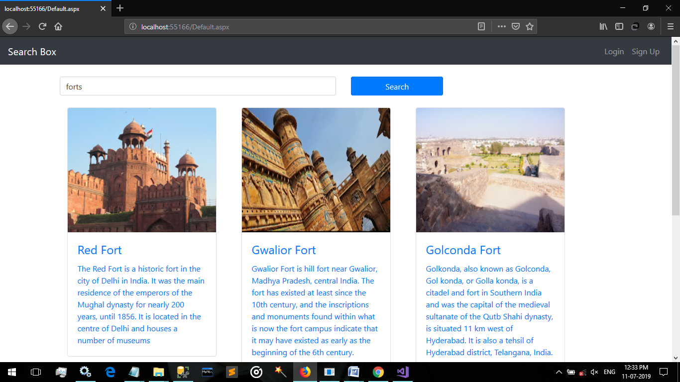

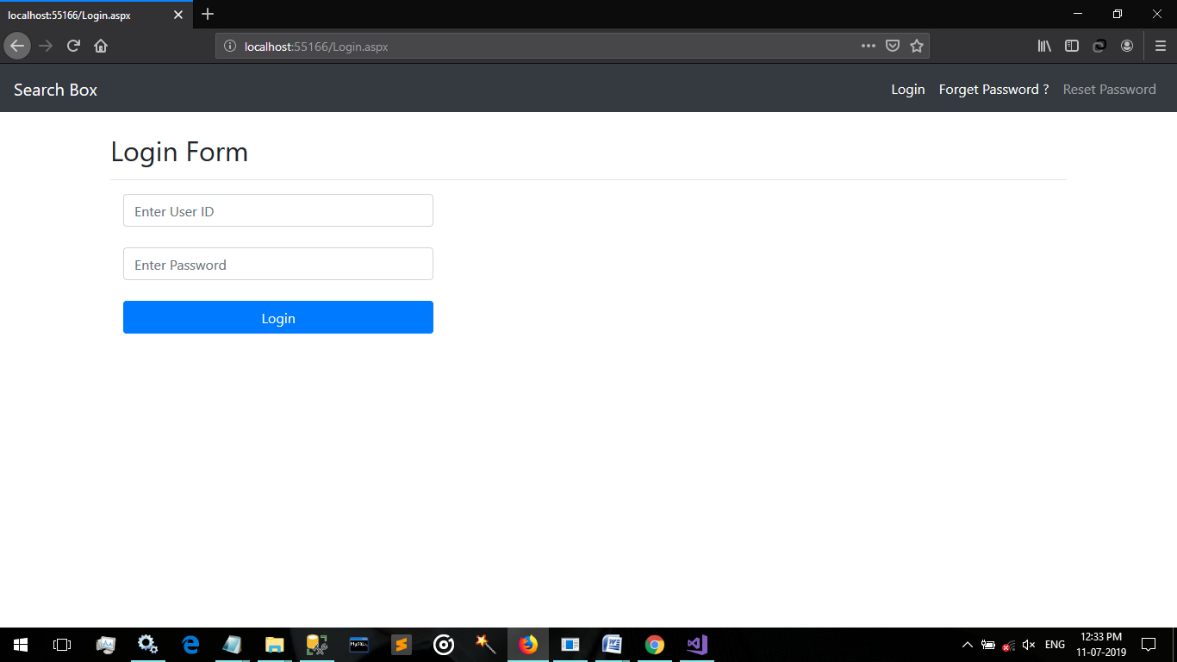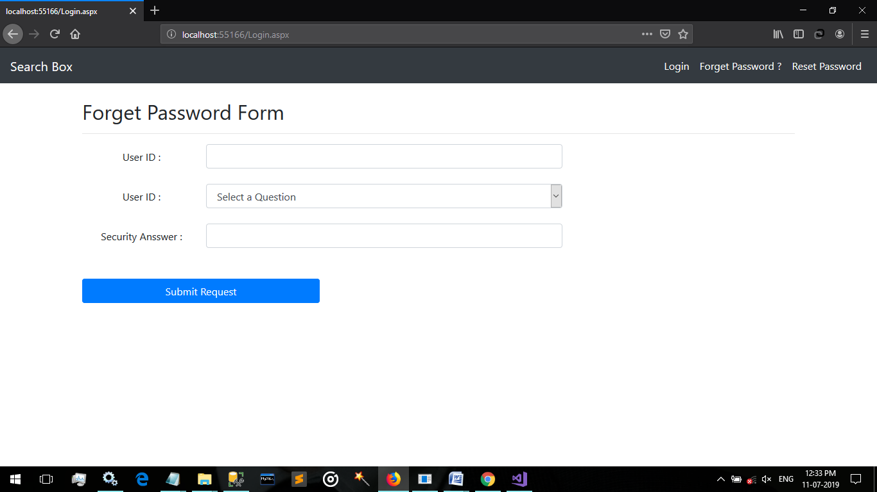 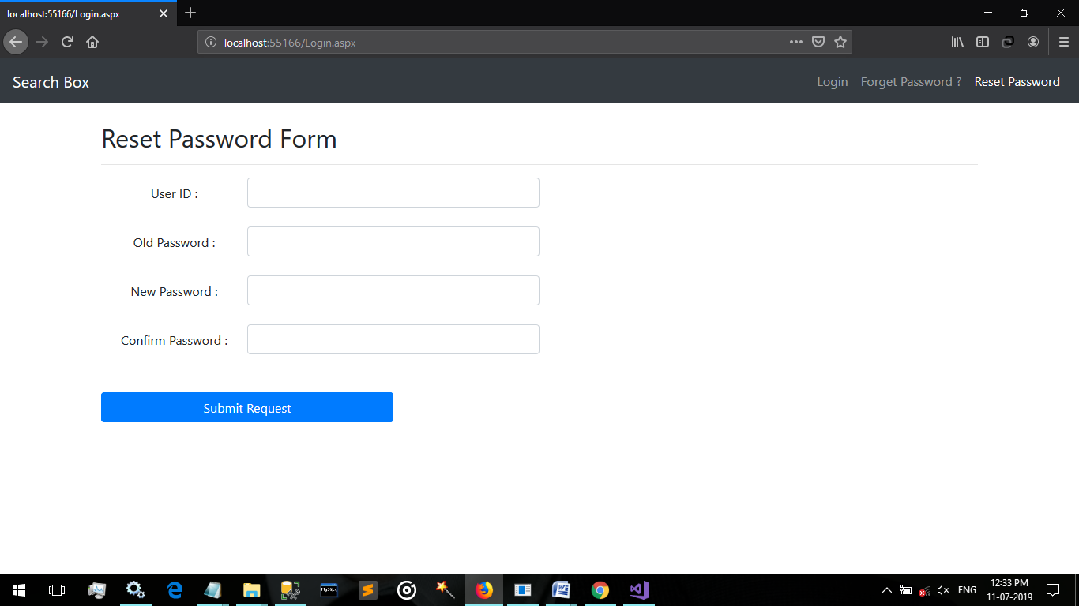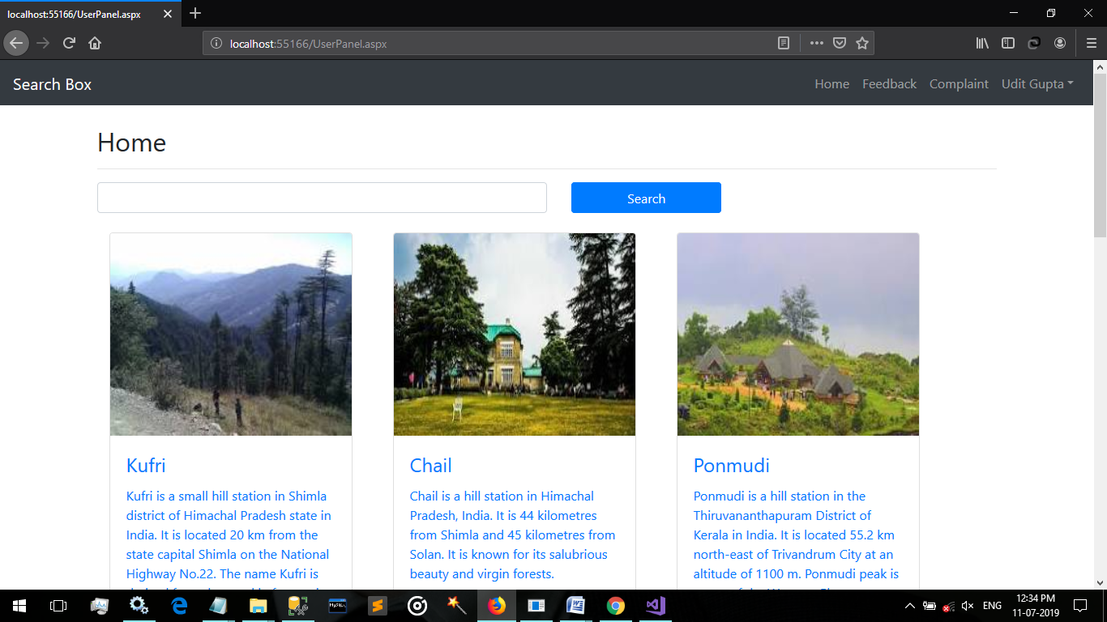 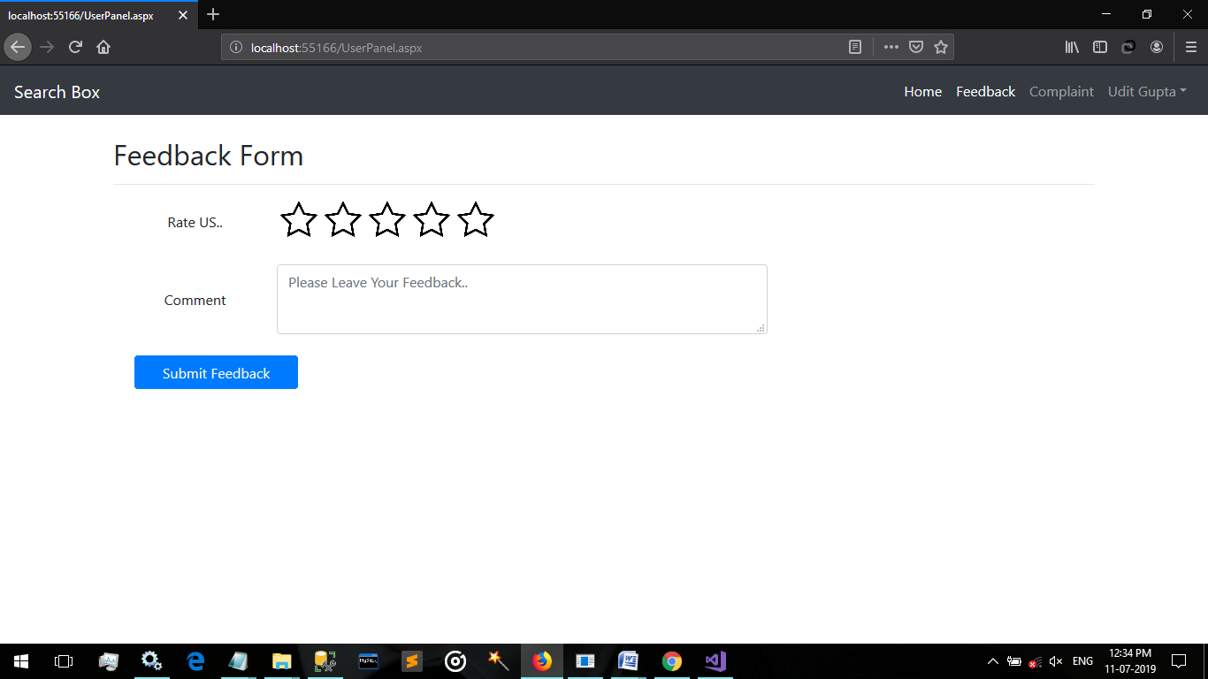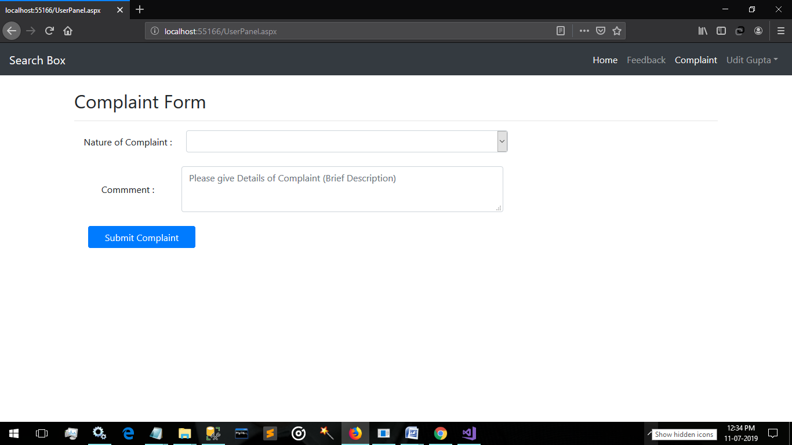 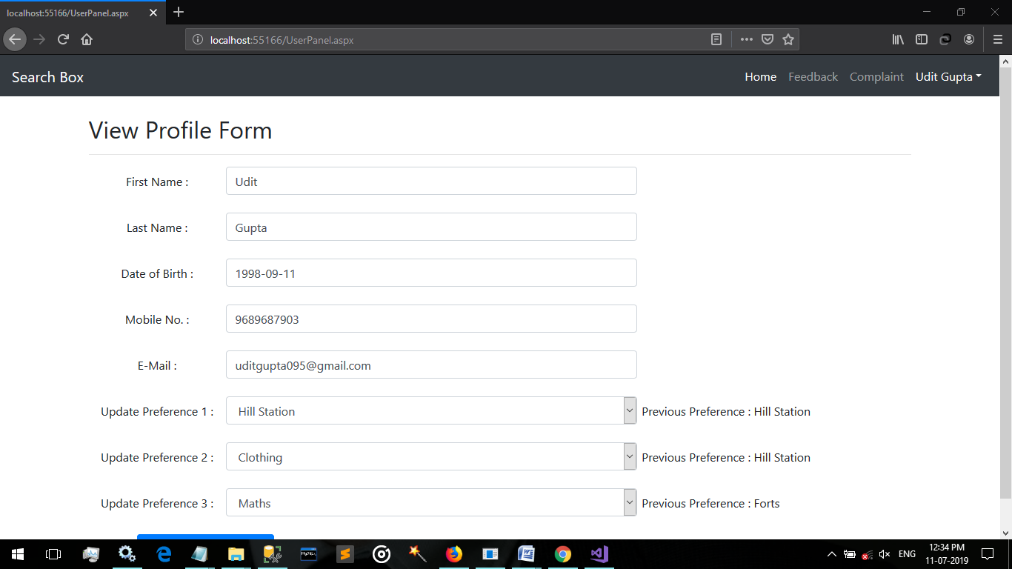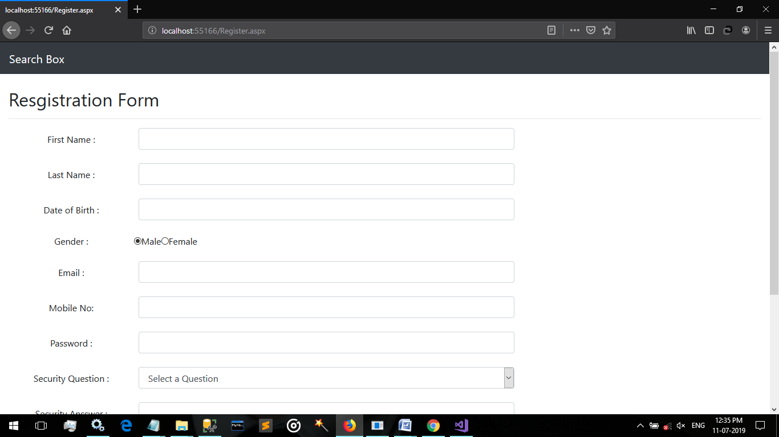 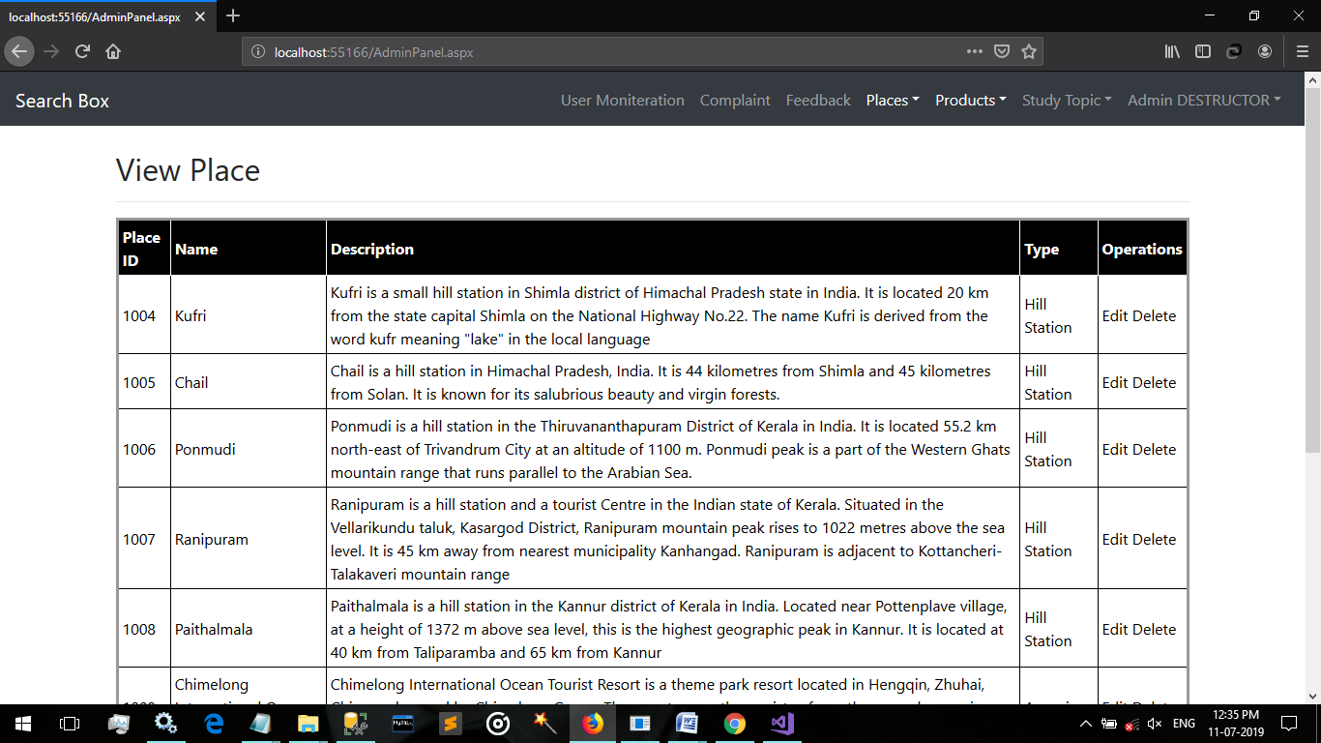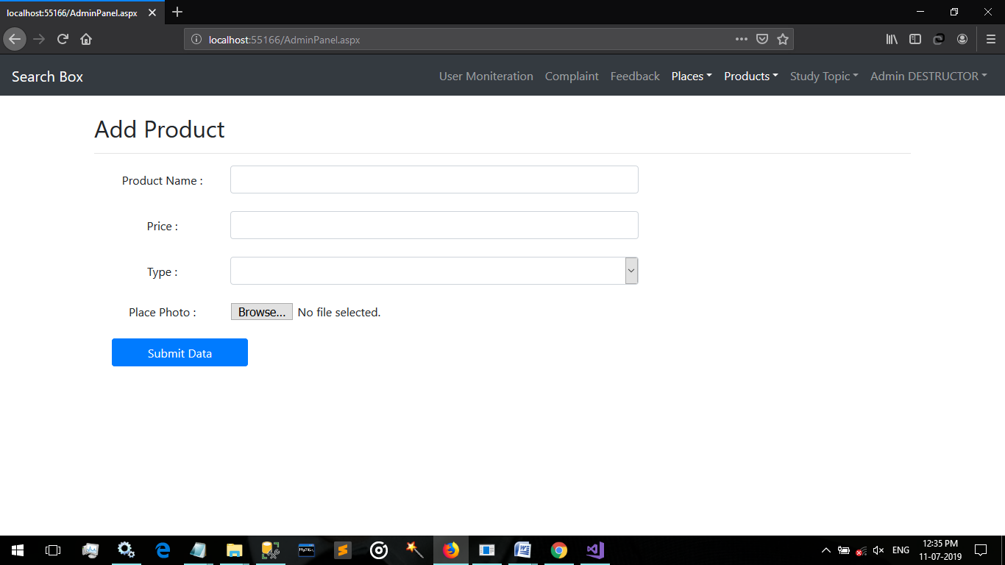 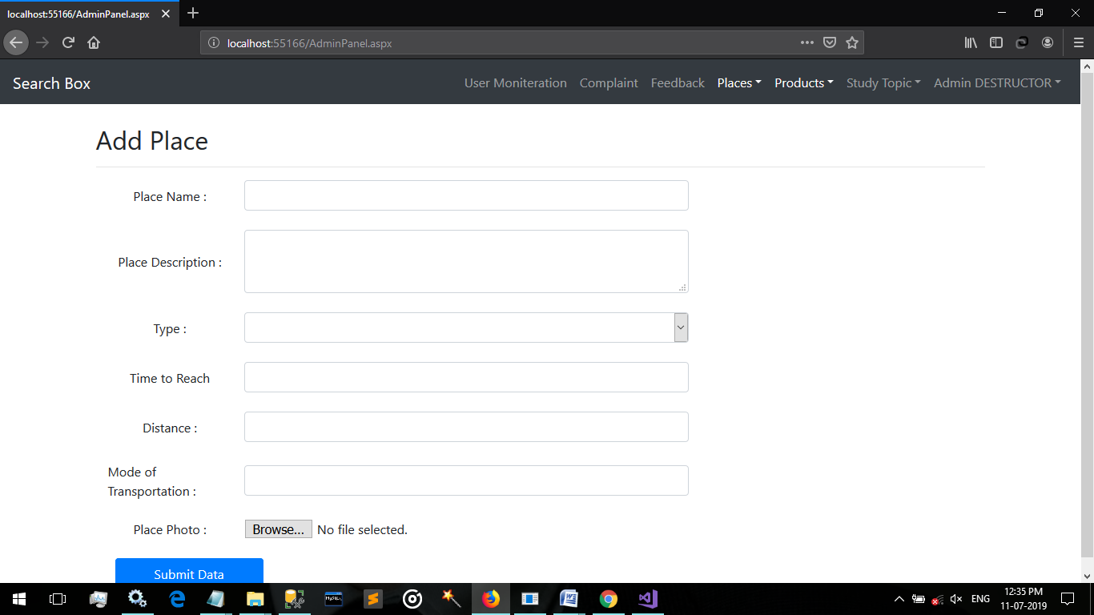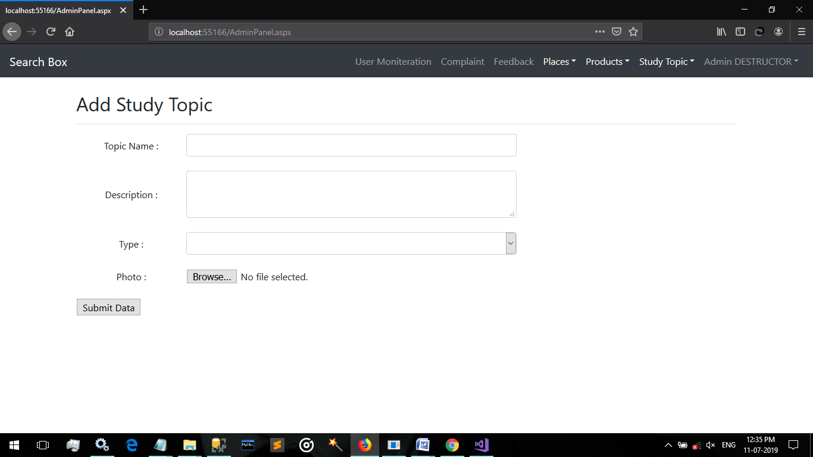 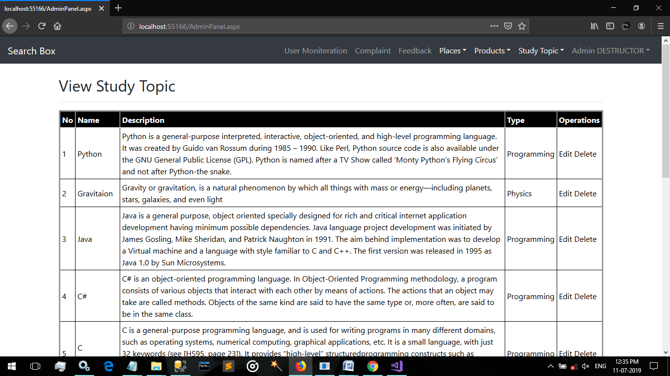

**Conclusion**

Search Box Application enables user to Search about Places, product & Study Material and Demonstrated Recommendation system for user to show only user preferred contents.